Source Data Mapping Approach to CDMV5.4

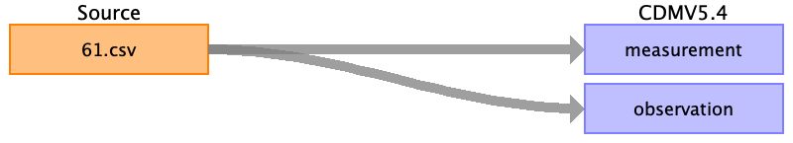

Table name: measurement

Reading from 61.csv

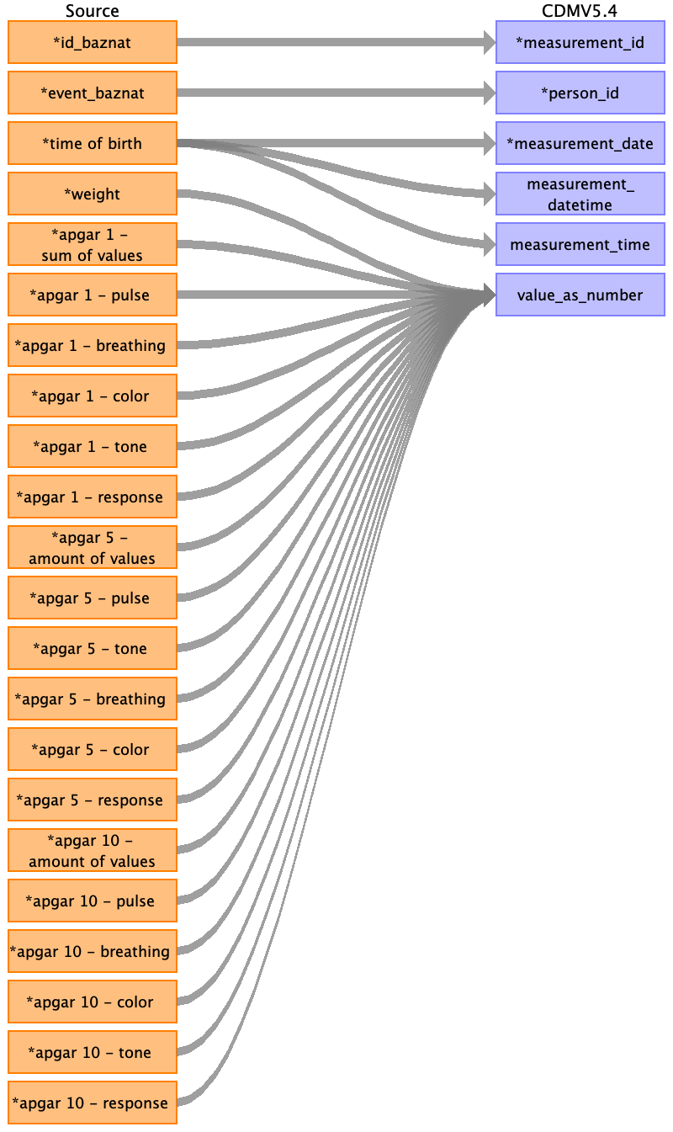

|  |  |  |  |
| --- | --- | --- | --- |
| Destination Field | Source Field | Logic | Comment |
| measurement_id | ﻿id_baznat |  |  |
| person_id | event_baznat |  |  |
| measurement_concept_id |  |  |  |
| measurement_date | time of birth | Extract date |  |
| measurement_datetime | time of birth | As is, datetime |  |
| measurement_time | time of birth | Extract time from datetime |  |
| measurement_type_concept_id |  |  |  |
| operator_concept_id |  |  |  |
| value_as_number | weight  apgar 1 - sum of values  apgar 5 - amount of values  apgar 10 - amount of values  apgar 1 - pulse  apgar 1 - breathing  apgar 1 - color  apgar 1 - tone  apgar 1 - response  apgar 5 - pulse  apgar 5 - tone  apgar 5 - breathing  apgar 5 - color  apgar 5 - response  apgar 10 - pulse  apgar 10 - breathing  apgar 10 - color  apgar 10 - tone  apgar 10 - response | value_as_number = weight  Set measurement_concept_id = 4264825  Set ONE_MINUTE_APGAR_SCORE measruement_concept_id= 3016704  Set ONE_MINUTE_APGAR_SCORE measruement_concept_id= 3016704  Set TEN_MINUTE_APGAR_SCORE = 3016162  Set ONE_MINUTE_APGAR_HEART_RATE = 3027152  Set ONE_MINUTE_APGAR_RESPIRATORY_EFFORT = 3023275  Set ONE_MINUTE_APGAR_COLOR = 3026329  Set ONE_MINUTE_APGAR_MUSCLE_TONE = 3013445  Set ONE_MINUTE_APGAR_REFLEX_IRRITABILITY = 3027666  Set FIVE_MINUTE_APGAR_HEART_RATE = 3026961  Set FIVE_MINUTE_APGAR_MUSCLE_TONE = 3027494  Set FIVE_MINUTE_APGAR_RESPIRATORY_EFFORT = 3024292  Set FIVE_MINUTE_APGAR_COLOR = 3025592  Set FIVE_MINUTE_APGAR_REFLEX_IRRITABILITY = 3028332  Set TEN_MINUTE_APGAR_HEART_RATE = 3007503  Set TEN_MINUTE_APGAR_RESPIRATORY_EFFORT = 3025485  Set TEN_MINUTE_APGAR_COLOR = 3005021  Set TEN_MINUTE_APGAR_MUSCLE_TONE = 3006474  Set TEN_MINUTE_APGAR_REFLEX_IRRITABILITY = 3022387 |  |
| value_as_concept_id |  |  |  |
| unit_concept_id |  |  |  |
| range_low |  |  |  |
| range_high |  |  |  |
| provider_id |  |  |  |
| visit_occurrence_id |  |  |  |
| visit_detail_id |  |  |  |
| measurement_source_value |  |  |  |
| measurement_source_concept_id |  |  |  |
| unit_source_value |  |  |  |
| unit_source_concept_id |  |  |  |
| value_source_value |  |  |  |
| measurement_event_id |  |  |  |
| meas_event_field_concept_id |  |  |  |

Table name: observation

Reading from 61.csv

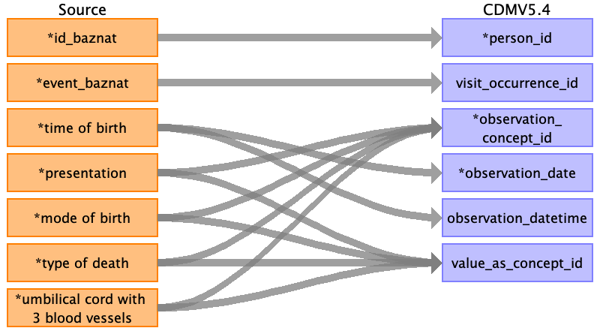

|  |  |  |  |
| --- | --- | --- | --- |
| Destination Field | Source Field | Logic | Comment |
| person_id | ﻿id_baznat |  |  |
| visit_occurrence_id | event_baznat |  | Check if the value exists in the target table visit_occurrence , if not set as None |
| observation_id |  |  | ID run |
| observation_concept_id | umbilical cord with 3 blood vessels  mode of birth  presentation  type of death |  | Set UMBILICUS_FINDING = 4096860  Set PATTERN_OF_DELIVERY = 4126390  Set PRESENTATION = 4084388  Set DEATH_DIAGNOSIS = 4052310 |
| observation_date | time of birth |  | Only date DD/MM/YYYY  Only date DD/MM/YYYY |
| observation_datetime | time of birth |  | Date and time - DD/MM/YYYY HH:MM:SS |
| observation_type_concept_id |  |  | Set EHR_CONCEPT_ID = 32817 |
| value_as_number |  |  | Value from source table. |
| value_as_string |  |  | Not use in this field. |
| value_as_concept_id | umbilical cord with 3 blood vessels  mode of birth  presentation  type of death |  | If 'כן' / 'yes' set UMBILICAL_CORD_NORMAL = 289315001  if 'לא' / 'no' set ABSENT_BLOOD_VESSEL_IN_UMBILICAL_CORD = 302945005  Using an auxiliary table.  Using an auxiliary table.  Using an auxiliary table. |
| qualifier_concept_id |  |  | Not use in this field. |
| unit_concept_id |  |  | Not use in this field. |
| provider_id |  |  | Not use in this field. |
| visit_detail_id |  |  | According to visit_occuerrence id and time. |
| observation_source_value |  |  | Not use in this field. |
| observation_source_concept_id |  |  | Not use in this field. |
| unit_source_value |  |  | Not use in this field. |
| qualifier_source_value |  |  | Not use in this field. |
| value_source_value |  |  | Not use in this field. |
| observation_event_id |  |  | Not use in this field. |
| obs_event_field_concept_id |  |  | Not use in this field. |

Table name: person

Table name: observation_period

Table name: visit_occurrence

Table name: visit_detail

Table name: condition_occurrence

Table name: drug_exposure

Table name: procedure_occurrence

Table name: device_exposure

Table name: death

Table name: note

Table name: note_nlp

Table name: specimen

Table name: fact_relationship

Table name: location

Table name: care_site

Table name: provider

Table name: payer_plan_period

Table name: cost

Table name: drug_era

Table name: dose_era

Table name: condition_era

Table name: episode

Table name: episode_event

Table name: metadata

Table name: cdm_source

Table name: cohort

Table name: cohort_definition

Appendix: source tables

Table: 61.csv

|  |  |  |  |
| --- | --- | --- | --- |
| Field | Type | Most freq. value | Comment |
| ﻿id_baznat | INT |  |  |
| event_baznat | INT |  |  |
| infant numer | INT |  |  |
| time of birth | INT |  |  |
| weight | INT |  |  |
| presentation | INT |  |  |
| cham_hosp_entry_date | INT |  |  |
| cham_hosp_exit_date | INT |  |  |
| age_category | INT |  |  |
| apgar 1 - sum of values | INT |  |  |
| apgar 1 - pulse | INT |  |  |
| apgar 1 - breathing | INT |  |  |
| apgar 1 - color | INT |  |  |
| apgar 1 - tone | INT |  |  |
| apgar 1 - response | INT |  |  |
| apgar 5 - amount of values | INT |  |  |
| apgar 5 - pulse | INT |  |  |
| apgar 5 - tone | INT |  |  |
| apgar 5 - breathing | INT |  |  |
| apgar 5 - color | INT |  |  |
| apgar 5 - response | INT |  |  |
| apgar 10 - amount of values | INT |  |  |
| apgar 10 - pulse | INT |  |  |
| apgar 10 - breathing | INT |  |  |
| apgar 10 - color | INT |  |  |
| apgar 10 - tone | INT |  |  |
| apgar 10 - response | INT |  |  |
| mode of birth | INT |  |  |
| stillbirth | INT |  |  |
| type of death | INT |  |  |
| cause of death death - comments | INT |  |  |
| a number will discuss giving birth | INT |  |  |
| umbilical cord with 3 blood vessels | INT |  |  |
| blood was taken | INT |  |  |
| through rescue | INT |  |  |
| birth notice | INT |  |  |
| sex | INT |  |  |
| record_date | INT |  |  |